GIT QUESTIONAIRE
MIS: 111803162
Name: Kanhaiya Madaswar

- What is Git, write atleast 5 points?
- Git is free and open-source software distributed under GNU General Public License Version 2.
- Git is a distributed version-control system for tracking changes in source code during software development.
- It is designed for coordinating work among programmers, but it can be used to track changes in any set of files.
- Its goals include speed, data integrity, and support for distributed, non-linear workflows.
- As with most other distributed version-control systems, and unlike most client–server systems, every Git directory on every computer is a full-fledged repository with complete history and full version-tracking abilities, independent of network access or a central server.
- What is the advantage & disadvantage of Git?
- Advantages -
- Good distributed model as each developer gets a local repository with a full history of commits which makes git fast compared to other VCs.
- Branching capabilities and merging are easy (as they are cheap), good data integrity.
- They are free and open-source we can easily download the source code and performs changes to it. They can handle larger projects efficiently.
- The push/pull operations are faster with a simple They save time and developers can fetch and create pull requests without switching.
- Disadvantages -
- GIT requires technical excellence and it is slower on windows. They have tedious command lines to input and doesn’t track renames.
- They have poor GUI and usability. And also, they take a lot of resources which slows down the performance.
- GIT doesn’t support checking out sub-trees. For each project, the central service would need to be set up for multiple package repositories.
- It lacks window support and doesn’t track empty folders.
- GIT needs multiple branches to support parallel developments used by the developers.
- Git is written in which language?
- C, Shell, Perl, Tcl, Python
- How will you create a repository in git?
- git init
- What does “git push” command do in Git?
- The git push command is used to upload local repository content to a remote repository. Pushing is how you transfer commits from your local repository to a remote repo.
- What is a commit message in Git?
- The commit command is used to save changes to a local repository after staging in Git. However, before you can save changes in Git, you have to tell Git which changes you want to save as you might have made tons of edits. A great way to do that is by adding a commit message to identify your changes.
- What's the difference between a "pull request" and a "branch"?
- Pull requests let you tell others about changes you've pushed to a GitHub repository. Once a pull request is sent, interested parties can review the set of changes, discuss potential modifications, and even push follow-up commits if necessary.
- A separate version of the code is branch.
- What is the difference between "git pull" and "git fetch"?
- When you use pull, Git tries to automatically do your work for you. It is context sensitive, so Git will merge any pulled commits into the branch you are currently working in. pull automatically merges the commits without letting you review them first.
- When you fetch, Git gathers any commits from the target branch that do not exist in your current branch and stores them in your local repository. However, it does not merge them with your current branchTo integrate the commits into your master branch, you use merge.
- How to revert previous commit in git?
- git revert <unwanted commit hash>.
- How to remove a file from git without removing it from your file system?
- To remove a single file: “git rm --cached mylogfile.log”.
- for a single directory: “git rm --cached -r mydirectory”.
- When do you use "git rebase" instead of "git merge"?
- Use merge in cases where you want a set of commits to be clearly grouped together in history.
- Use rebase when you want to keep a linear commit history.
- DON’T use rebase on a public/shared branch.
- Explain the Gitflow workflow with neat diagram?
- GitFlow is a branching model for Git, created by Vincent Driessen. It is very well suited to collaboration and scaling the development team. Gitflow utilizes the core feature of Git, which is the power of branches. In this model, a repository has two core branches:
- Master/Main - This is a highly stable branch that is always production-ready and contains the last release version of source code in production. (For the purposes of this article, we will be referring to this branch as “main”).
- Develop - Derived from the main branch, the development branch serves as a branch for integrating different features planned for an upcoming release. This branch may or may not be as stable as the main branch. It is where developers collaborate and merge feature branches.
Apart from those two primary branches, there are other branches in the workflow:
- Feature - This derives from the develop branch and is used to develop features.
- Release - This also derives from develop branch but is used during releases.
- Hotfix - This derives from the main branch and is used to fix a bug in the production branch that was identified after a release.
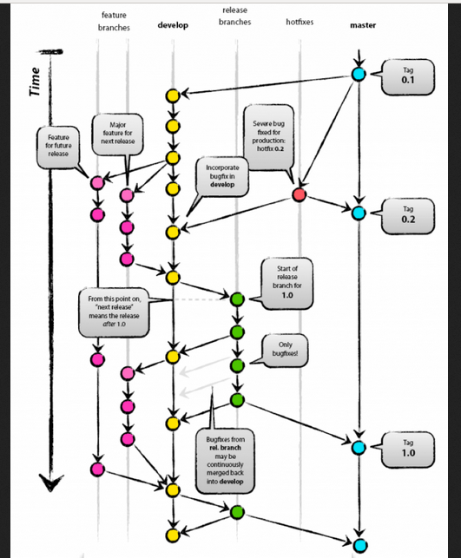

- How can we see 'n' most recent commits in GIT?
- “git log -<n>” lists the commits made in that repository in reverse chronological order; that is, the most recent commits show up first.
- How can we know if a branch is already merged into master in GIT?
- The git merge-base command finds the latest common commit between the two branches. If that commit is the same as your branch head, then the branch has been completely merged.
- What is the most popular branching strategy in GIT?
- There are many ways to do branching in GIT. One of the popular ways is to maintain two branches:
- master: This branch is used for production. In this branch HEAD is always in production ready state.
- develop: This branch is used for development. In this branch we store the latest code developed in project. This is work in progress code.
Once the code is ready for deployment to production, it is merged into master branch from develop branch.
- How to delete a branch in Git?
- git branch -d local_branch_name // delete branch locally
- git push origin --delete remote_branch_name // delete branch remotely
- How do you clean unwanted files from working directory in Git?
- If you want to see which files will be deleted, use the -n option before you run the actual command: git clean -n
- Then when you are comfortable (because it will delete the files for real!) use the -f option: git clean -f
- How can we determine the commit that is the source of bug in Git?
- “git-bisect” - Use binary search to find the commit that introduced a bug
- How can we see differences between two commits in Git?
- “git diff <commit-id> <commit-id>”
- What is cherry-pick in Git?
- “git cherry-pick” is a powerful command that enables arbitrary Git commits to be picked by reference and appended to the current working HEAD.
- Cherry picking is the act of picking a commit from a branch and applying it to another.
- “git cherry-pick” can be useful for undoing changes. For example, say a commit is accidently made to the wrong branch. You can switch to the correct branch and cherry-pick the commit to where it should belong.
- What is the use of Git log command?
- The Git Log tool allows you to view information about previous commits that have occurred in a project.
- The simplest version of the log command shows the commits that lead up to the state of the currently checked out branch. These commits are shown in reverse chronological order (the most recent commits first).
- What is the purpose of stash command in Git?
- Stashing takes the dirty state of your working directory - i.e. your modified tracked files and staged changes and saves it on a stack of unfinished changes that you can reapply at any time (even on a different branch).
- What is the use of status command in Git?
- Displays paths that have differences between the index file and the current HEAD commit, paths that have differences between the working tree and the index file, and paths in the working tree that are not tracked by Git (and are not ignored by gitignore).
- Explain the use of git rerere?
- The name stands for “reuse recorded resolution”.
- it allows you to ask Git to remember how you’ve resolved a hunk conflict so that the next time it sees the same conflict, Git can resolve it for you automatically.
- Name atleast 5 GUI used for working on Git?
- SmartGit
- Git Extensions
- GitKraken
- Visual Studio Code
- Source Tree
- GitUp
- Gitcola
- Gitg

